Participant Registration Form

Welcome to Nordic Walking For Beginners Before you start please complete this form so your walk leader knows your level of fitness and any specific health problems you have.

Please print clearly in block capitals. Your Nordic walk is provided by Epping Forest District Council Community Health and Wellbeing, supporting you to get active and stay active.

NOTE to Nordic Walking staff and volunteers: This form will contain sensitive or personal data once completed and must be handled and stored securely. Please issue a ICE card to every participaint

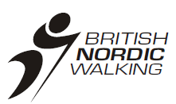

1. Gender: 9. Have you been recommended by your doctor/ or a health professional to come on this scheme?
􀈽 Male 􀈽 Female
􀈽Yes 􀈽No

2. Title (Mr, Ms, etc...):

10. For most people, physical activity does not pose a hazard. The questions below have been designed to identify the small number of people who should seek medical advice before starting. Yes No
a. Has a doctor ever said you have
a heart condition? 􀈽 􀈽
b. Do you feel pain in your chest when
you do physical activity? 􀈽 􀈽
c. Do you ever lose balance because of
dizziness or ever lose consciousness? 􀈽 􀈽
d. In the past month have you had pain in
your chest when you were NOT doing physical
activity? 􀈽 􀈽
e. Do you have a bone or joint problem that
could be made worse by a change in your
physical activity? 􀈽 􀈽
I understand that if I have answered yes to any of the previous Health Screening questions, I must seek medical advice before attending a walk. I agree to tell the walk leaders if there is a change in my medical condition and update my ICE card.
I understand that I walk at my own risk.
Signed:
___________________________________________

Date: _____________________________________

3. Name:

Surname:

Forename:

4. Address:

5. County:

6. Postcode:

7. Telephone number/ mobile:

8. Email:

Community Health and Wellbeing would like to contact you to tell you more about other events that are going on.

How would you like to be contacted? Tick all that apply.
􀈽 Post 􀈽 Phone
􀈽 Email 􀈽 Please don’t contact me

Signed:

_________________________________________

Date:
_________________________________________

Thank you for completing this questionnaire
You will be given an Incase Of Emergency Card please keep this on you at all times when taking part in Nordic Walking

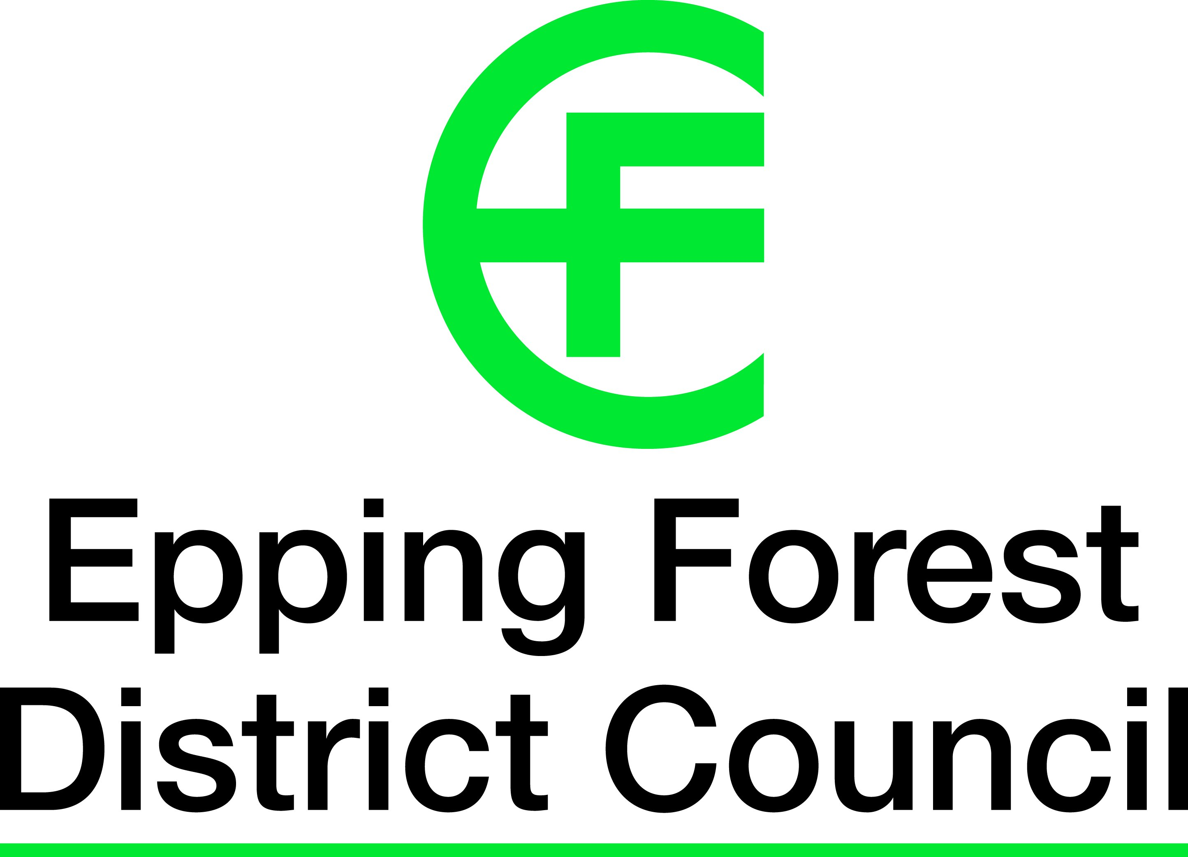

Name of emergency contact, relationship and phone number:

Name:

Phone Number:

Relationship to you:

Relevant medical information: (include any allergies/ injury problems)

I have completed the medical details above and I consent that, in the event of any illness/ accident, any necessary treatment can be administered, which may include the use of anaesthetics.

Signature:

Date:

We will collect and process all personal data in line with the Data Protection Act 1998. The information you have given will be used to monitor the success of the programme and help us plan for future sporting activities

PHOTOGRAPHY/FILMING - There may be filming and photography at some EFDC sessions which may be used in publicity materials e.g. leaflets, newsletters or on official websites. Images when used will not be accompanied by names or details that could identify individuals.
I DO / DO NOT give permission to be filmed or photographed during as described above (Please delete as appropriate).

